**INSTRUCTIONS**

**Please read the instructions carefully before doing the questions.**

* You are **NOT allowed** to use any device to share data with others.
* You must use **Visual Studio 2019 or above, MSSQL Server 2008 or above** for your development tools.

**IMPORTANT – before you start doing your solution, MUST do the following steps:**

1. Create Solution/Project in Visual Studio named **PRN221_TrialTest_StudentFullName**.
2. You can choose **Windows Presentation Foundation** MVVM or Razor Pages MVVM.
3. Create your MS SQL database named **BookPublisher** by running code in script **BookPublisher.sql.**
4. Set the default user interface for your project as **Login** page.

Create an application using WPF (or ASP.NET Core Razor Pages) with .NET Core, C#, and ADO.NET (or Entity Framework). A MS SQL Server database will be created to persist the data and it will be used for reading and managing data.

**Book-Publisher** management database

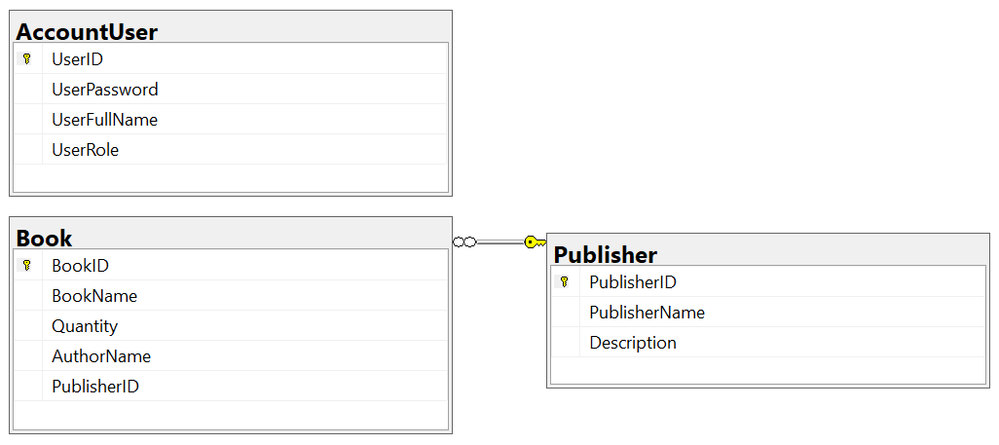

*Account role: Administrator = 1; Manager = 2; Staff = 3*

***Note***

Install package using Tools → NuGet Package Manager → Package Manager Console

Install-Package Microsoft.EntityFrameworkCore.SqlServer -Version 5.0.14

Install-Package Microsoft.EntityFrameworkCore.Tools -Version 5.0.14

Install-Package Microsoft.EntityFrameworkCore.Design -Version 5.0.14

Install-Package Microsoft.Data.SqlClient -Version 3.0.1

- Install package using CLI or Power Shell

dotnet add package Microsoft.EntityFrameworkCore.SqlServer --version 5.0.14

dotnet add package Microsoft.EntityFrameworkCore.Design --version 5.0.14

dotnet add package Microsoft.EntityFrameworkCore.Tools --version 5.0.14

dotnet add package Microsoft.Data.SqlClient --version 3.0.1

- Connection String

"Server=(local);Uid=sa;Pwd=**1234567890**;Database= **BookPublisher** "

Entity Framework Core

*- Install dotnet-ef for CLI*

dotnet tool install --global dotnet-ef --version 5.0.11

*- Use Entity Framework Core to generate Object Model from existing database – CLI*

dotnet ef dbcontext scaffold "Server=(local);Uid=sa;Pwd=**1234567890**;Database=**BookPublisher**" Microsoft.EntityFrameworkCore.SqlServer --output-dir Models

*- Generate database from domain classes – CLI.*

dotnet ef migrations add "InitialDB"

dotnet ef database update

Entity Framework Core

*- Use Entity Framework Core to generate Object Model from existing database – Package Manager Console*

Scaffold-DbContext "Server=(local);Database= **BookPublisher**;Uid=sa;Pwd=1234567890;" Microsoft.EntityFrameworkCore.SqlServer -OutputDir Models

*- Generate database from domain classes – Package Manager Console*

Add-Migration "InitialDB"

Update-Database -verbose